CareConnect Desktop Design Documentation
SWEN 661 - Assignment 7: Desktop Design and Early Implementation

Team: Team 10
Members: Chastity Sapp, Joriel Rivas, Henry Stewart
Institution: University of Maryland Global Campus
Course: SWEN 661 - User Interface Implementation
Instructor: Dr. Alireza Minagar
Date: February 24, 2026

1. Deliverables Checklist
The following deliverables are included in this submission in accordance with the Assignment 7 requirements for SWEN 661. Each item has been completed and is documented within this report.
- Figma screenshots of all desktop UI screens (6 screens)
- Keyboard shortcut table (12 shortcuts documented)
- Accessibility plan tailored to our assigned constraint
- Test plan with all happy paths and at least three sad paths
- AI usage statement
2. Figma Screenshots
The screens below were designed in Figma for CareConnect's desktop interface, targeting a minimum resolution of 1280x800 pixels. All screens share a persistent left-sidebar navigation panel, a native-style menu bar, keyboard-first interaction patterns, and WCAG 2.1 AA compliant accessibility styling. Each screen reflects real desktop application conventions rather than a stretched mobile layout.

2.1 Welcome page and Choose your Role
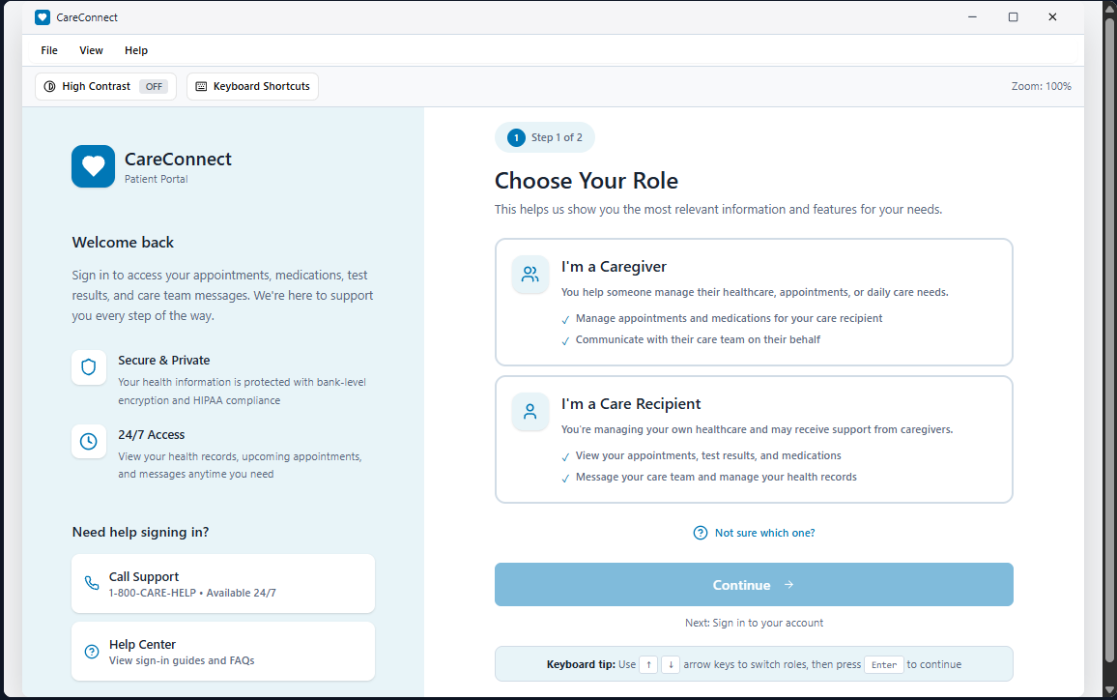
Figure 2.1: The Welcome and Choose Your Role screen introduces CareConnect in a calm, low-cognitive-load desktop layout that helps users orient themselves before signing in. It uses a two-panel structure, with reassurance and support resources on the left and a guided role selection step on the right. The role cards are large, clearly labeled, and designed for keyboard-first selection with a strong visual selected state so users can confidently confirm their choice before continuing. This design reduces confusion by keeping choices minimal and presenting a clear next step.

2.2 Sign In
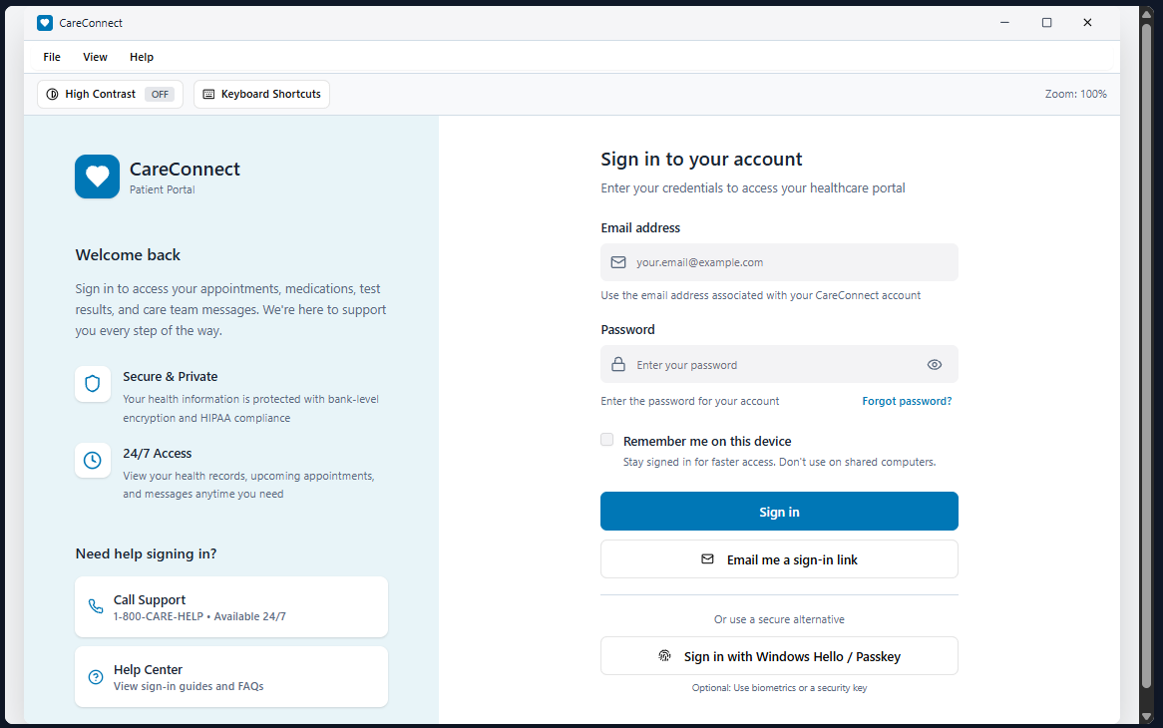
Figure 2.2: The Sign In screen provides a desktop-optimized login experience using visible labels, helper text, and clear grouping of actions to reduce user error. The layout prioritizes recognition over recall by keeping support options visible in the left panel while the right panel focuses on the form. Primary and secondary sign-in actions are visually distinct, and the interface supports accessibility through readable spacing, large click targets, and predictable form structure. This screen is designed to work well for both mouse and keyboard workflows.

2.3 Sign In – Keyboard Focus
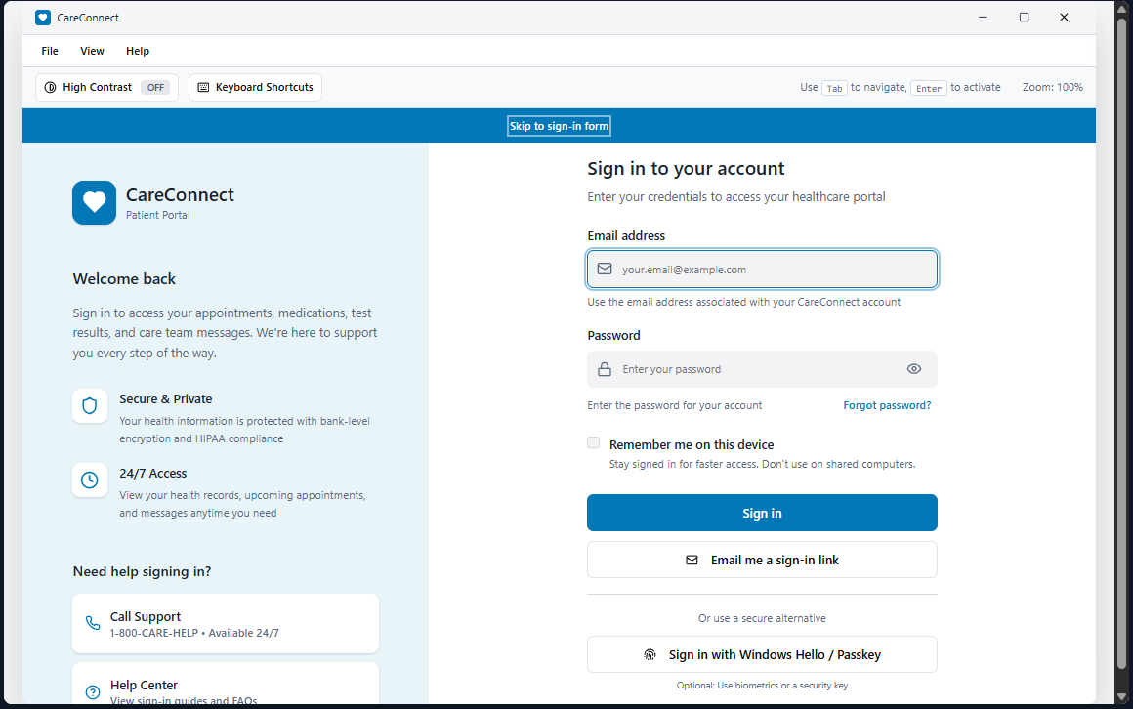
Figure 2.3: This frame demonstrates the keyboard-first design by showing a clear focus ring on the active control and a skip link that appears when navigating by keyboard. The tab order follows a logical top-to-bottom flow, ensuring users can move through the form without losing their place. The screen also includes gentle guidance for keyboard navigation so users know what to do next without needing extra instruction. This frame serves as evidence that focus visibility and keyboard navigation were planned intentionally, not added as an afterthought.

2.4 Sign in – Error State
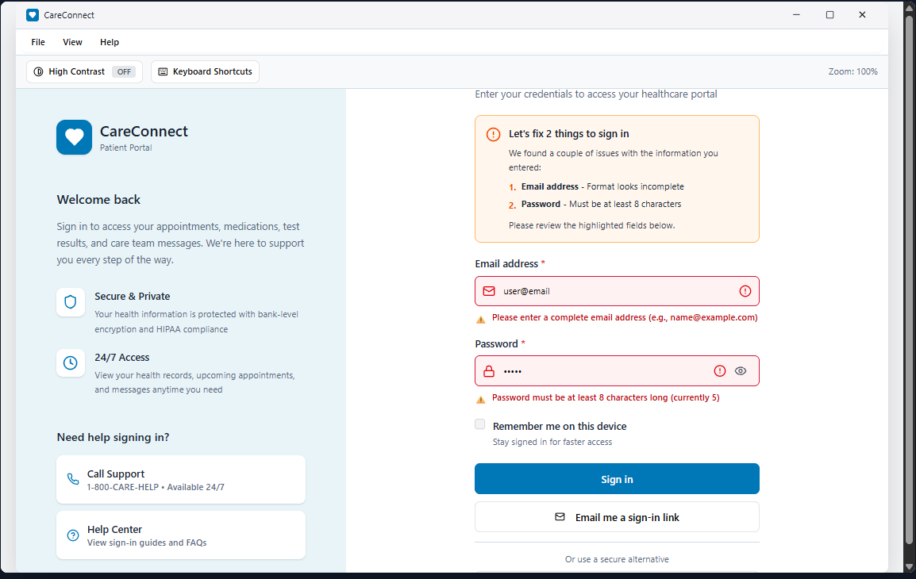
Figure 2.4: The Error State frame shows how the interface handles mistakes in a supportive, non-punitive way. Instead of relying on harsh alerts, it uses an accessible error summary and inline field guidance that clearly explains what needs to be fixed and why. Recovery actions are included to help users move forward, such as password recovery or alternative sign-in options, which prevents users from getting stuck. This approach supports accessibility by making errors easy to identify, understand, and resolve using either keyboard or mouse

2.5 Keyboard Shortcuts
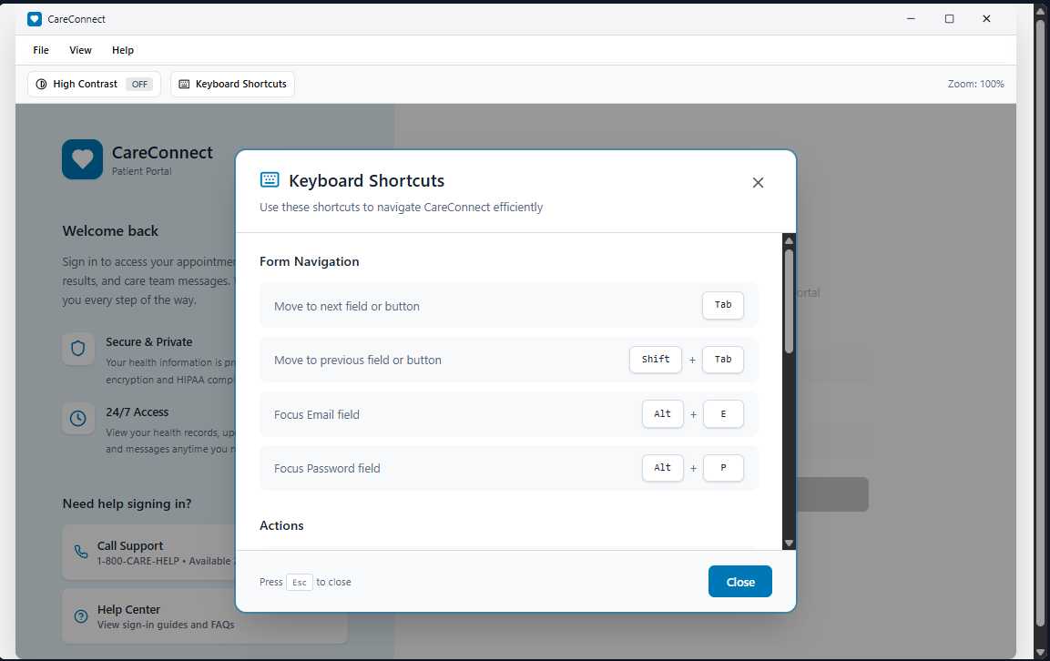
Figure 2.5: The Keyboard Shortcuts modal provides a quick reference for essential navigation and action shortcuts so users can operate the desktop application efficiently without a mouse. The list is organized for fast scanning and includes common patterns that align with desktop conventions, such as focus movement, opening help, and closing dialogs. The modal is designed to be keyboard accessible, with a clear close action and expected dismissal behavior. This feature supports both usability and accessibility by reducing cognitive effort and reinforcing consistent interaction patterns.

2.6 Home Dashboard
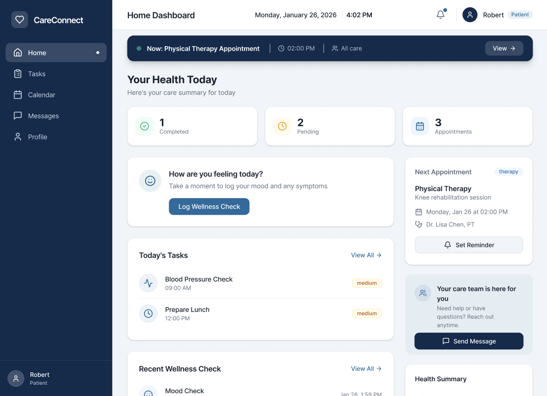
Figure 2.6: Home Dashboard. The Home Dashboard serves as the primary entry point for the application. It surfaces a real-time summary of the patient's health today, including completed tasks, pending items, and upcoming appointments. A wellness check prompt encourages daily mood and symptom logging. The right panel shows the next scheduled appointment with a one-click reminder option, and a care team contact card is always visible for quick access to messaging.

2.7 Tasks Screen
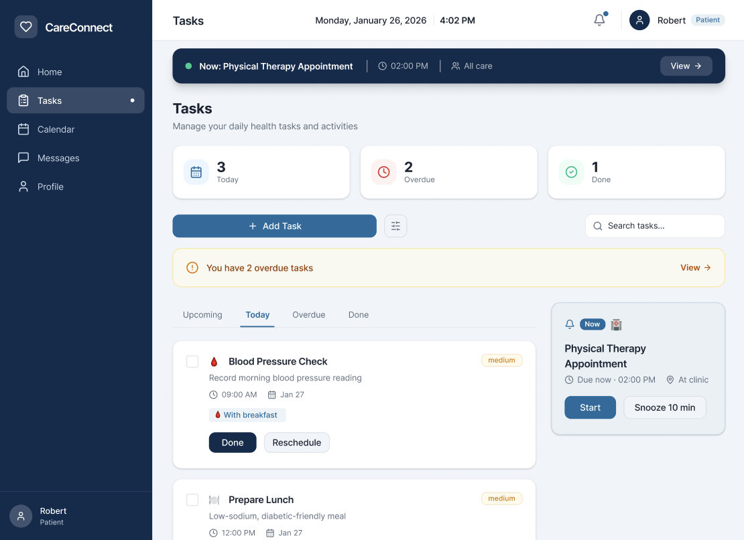
Figure 2.7: Tasks Screen. The Tasks screen gives users a structured view of their daily health activities. Summary cards at the top display counts for today's tasks, overdue items, and completed ones. A persistent overdue alert banner draws immediate attention to time-sensitive items. Each task card shows its scheduled time, associated context (such as meal pairing), and action buttons for completing or rescheduling. A tab bar allows quick switching between Upcoming, Today, Overdue, and Done views.

2.8 Calendar Screen
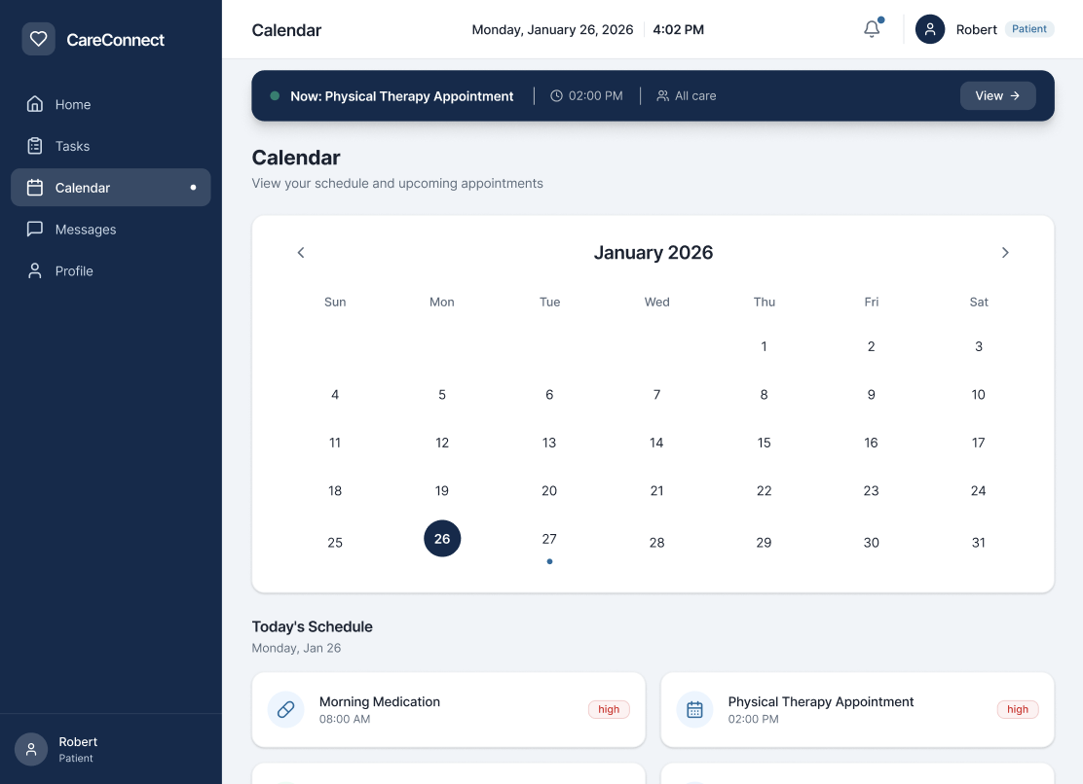
Figure 2.8: Calendar Screen. The Calendar screen provides a full monthly view with today highlighted. A dot indicator marks days with scheduled events. Below the calendar, Today's Schedule lists all appointments and tasks for the current day, each labeled with a priority level. This screen helps patients and caregivers plan ahead and coordinate care activities across the week.

2.9 Health Logs Screen
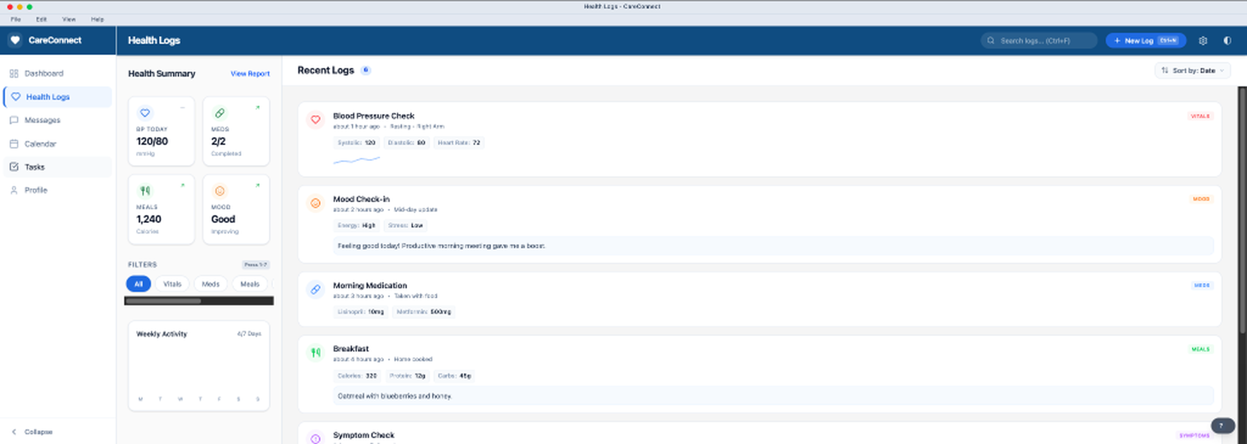
Figure 2.9: Health Logs Screen. The Health Logs view provides a centralized feed of all recent health activity. The left panel displays a summary of key metrics including today's blood pressure reading (120/80), medications taken, calorie intake, and mood status. The main content area lists recent log entries in reverse chronological order, each tagged by category: Vitals, Meds, Meals, or Symptoms. A filter bar allows users to quickly isolate entries by type, and a date-sorted view helps caregivers track trends at a glance.

2.10 Messages Screen
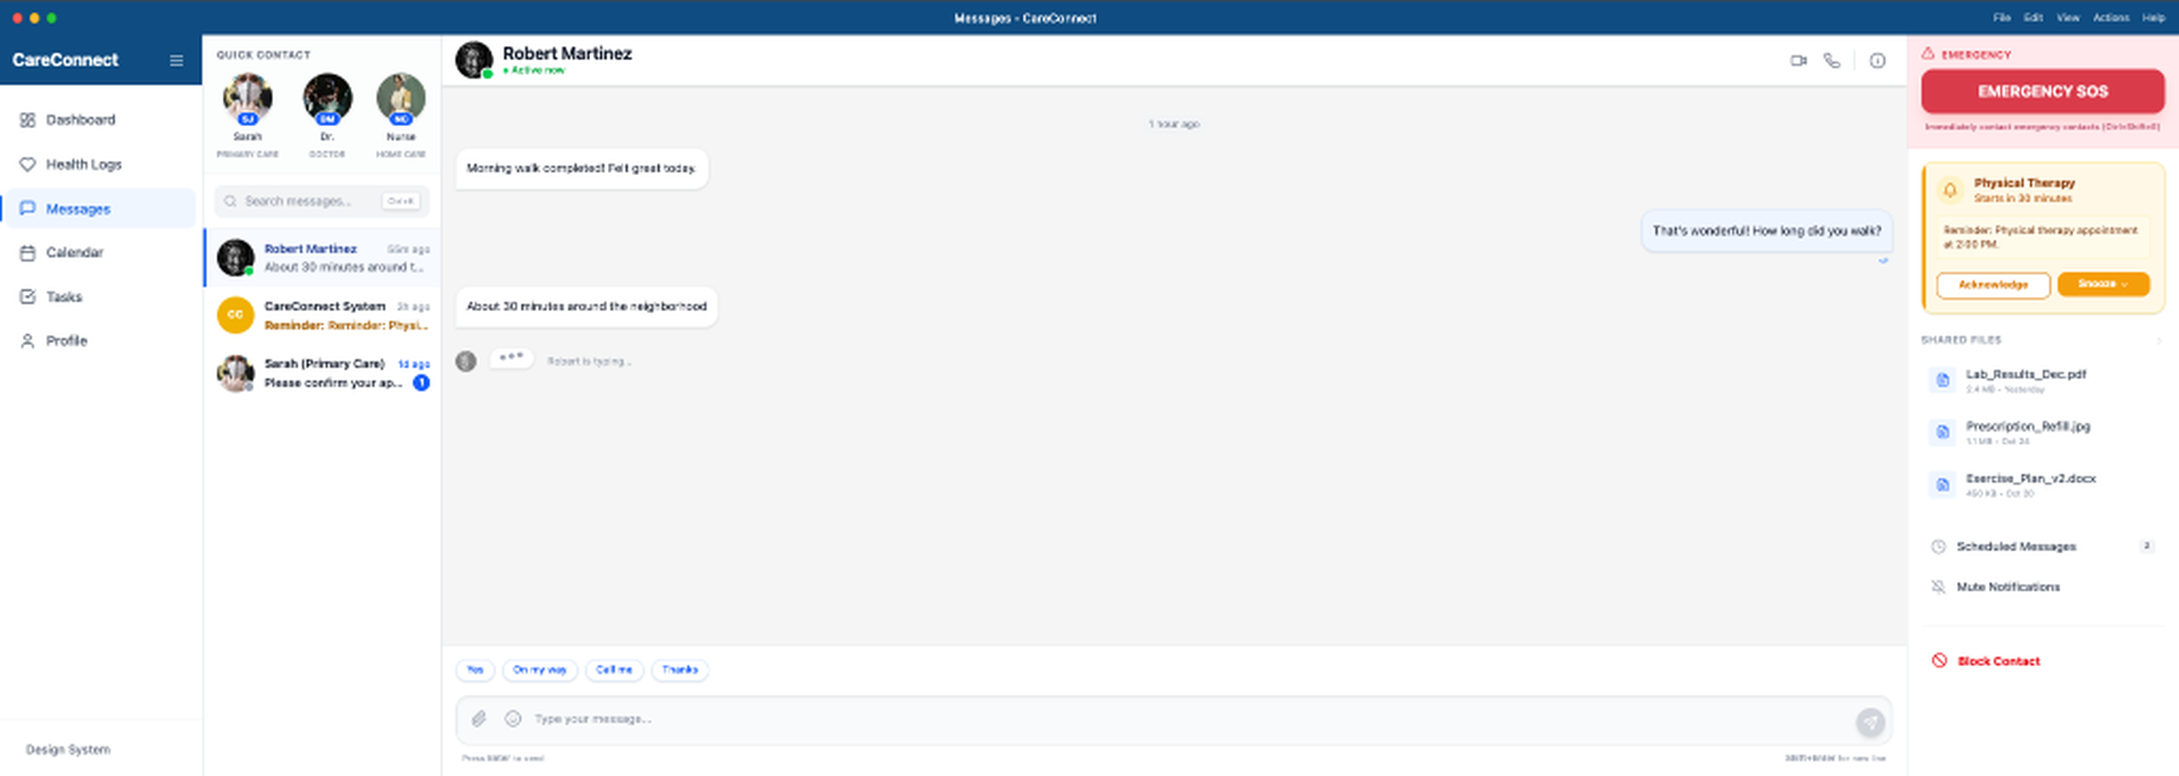
Figure 2.10: Messages Screen. The Messages screen features a three-panel layout: a Quick Contact strip at the top for pinned care team members, a conversation list on the left, and the active thread in the center. A persistent Emergency SOS button is anchored in the upper-right corner for immediate access. The right panel surfaces contextual information including upcoming reminders, shared files, and notification preferences. Quick-reply suggestions at the bottom of the chat window reduce typing effort for common responses.
2.11 Profile and Settings Screen
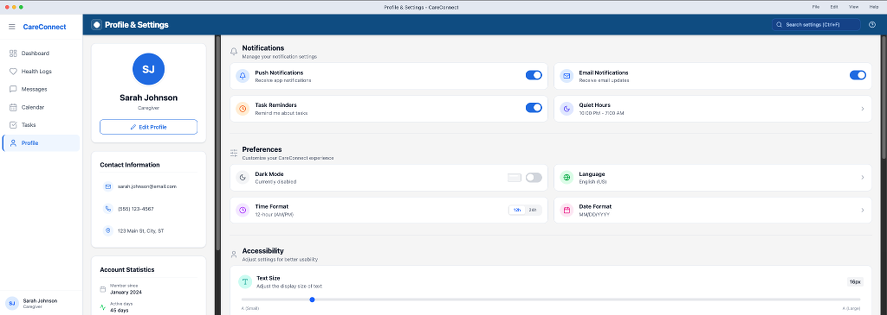
Figure 2.11: Profile and Settings Screen. The Profile and Settings screen is organized into clearly labeled sections: Notifications, Preferences, and Accessibility. Users can manage push and email notifications, set quiet hours, toggle dark mode, select language and date/time formats, and adjust text size through a slider. The left panel displays the user's profile information and account statistics. All controls are fully keyboard-navigable and labeled for screen reader compatibility.

3. Desktop Design System (Components)
This section documents the desktop design system components used across the CareConnect desktop screens. The goal is a calm, structured, low-cognitive-load experience for STML users while still following standard desktop conventions.

3.1 Window chrome and desktop frame structure
The desktop layout is designed to look and feel like a real desktop application window instead of a stretched mobile screen. The window uses a title bar with the CareConnect icon and title plus standard window controls. Below the title bar, a menu bar remains visible at all times to support predictable access to actions. A toolbar row is placed under the menu bar to surface a small set of frequently used controls that help users quickly adjust accessibility settings or access help. The main content area follows a two-panel layout so reassurance and help are separated from primary tasks. The overall layout uses consistent safe padding so content does not touch the window edges and the interface remains calm and readable.

3.2 Menu bar pattern
The menu bar follows common desktop expectations and is designed to support keyboard-first use. It stays visible at the top of the app window and uses familiar menu names so users can predict where actions will be located. The menu structure is intended to align with standard desktop navigation conventions, including common access patterns on Windows, while keeping labels simple to reduce cognitive load for STML users.

3.3 Toolbar pattern (quick access actions)
The toolbar provides quick access to high frequency actions without requiring users to search through menus. It includes a High Contrast toggle to support visibility needs, a Keyboard Shortcuts button to open the shortcuts reference, and a zoom indicator that shows the current zoom level and supports zoom controls through the View menu and shortcuts. This approach supports STML users by keeping the most important support and accessibility tools visible and easy to reach.

3.4 Sidebars and panels
The desktop layout uses a two-panel structure to support clear orientation and low confusion. The left panel acts as a stable support area that includes branding, reassurance text, and a help block such as “Need help signing in?” with direct support actions. The right panel is the primary task area and presents the user flow in guided steps, such as choosing a role and then signing in. This separation helps users stay anchored, because supportive guidance remains in a consistent location while the task flow stays structured on the right.

3.5 Dialogs and modals
Dialogs and modals are used to present focused reference content without adding clutter to the main screens. The Keyboard Shortcuts modal is designed to be easy to scan and includes a clear close action. It supports expected keyboard behavior, including Escape to close, and it keeps keyboard focus contained while the modal is open. This supports keyboard-only workflows and reduces confusion for STML users by preventing focus from moving unpredictably behind the modal.

3.6 Context menus (right-click)
Context menus are included in the design system for future desktop screens that involve lists and item actions, such as Tasks or Messages. A right-click on a list item can reveal a short menu of actions, but these actions are intentionally limited to avoid decision overload. No core feature relies on right-click alone, because all actions will also be available through menu items, toolbar actions, or visible buttons so that keyboard-only use remains fully supported.

3.7 Status bar
A status bar is included in the desktop design system for post-login screens and general window feedback. It can display lightweight system messages such as saved state, syncing state, or offline state. It can also display helpful indicators such as zoom status or an accessibility mode indicator when High Contrast is enabled. This provides continuous feedback in a predictable location without interrupting the user flow.

3.8 Desktop-sized components and density rules
Desktop screens allow denser layouts than mobile, but this design still prioritizes clarity for STML users. Interactive controls remain large enough to select comfortably and spacing remains consistent to avoid visual clutter. Content is grouped into short, clearly labeled sections so users do not face long paragraphs or excessive choices at once. The visual hierarchy is designed to reduce scanning stress by guiding attention through headings, short helper text, and predictable placement of primary actions.

4. Desktop Wireframes and Responsive Behavior
This section explains how the desktop layout adapts across required window widths and how the interface behaves when resized. The design supports a minimum window size without breaking the core flow, while maintaining a calm and structured experience for STML users.
4.1 Wireframe width targets (1024px, 1440px, 1920px)
At 1024px wide, the two-panel layout becomes more space constrained, so the interface reduces complexity while preserving the guided flow. The support content on the left compresses into a smaller support area or becomes a toggle so the primary task content remains central and readable. Buttons remain visually obvious and the flow remains step-based so users can still complete role selection and sign-in without losing orientation. At 1440px wide, the two-panel layout is fully visible and becomes the primary reference design, with stable reassurance content on the left and the guided task flow on the right. White space is used intentionally to reduce visual clutter and improve readability. At 1920px wide, the interface avoids stretching into an overly wide layout by keeping the app content centered with a reasonable maximum width. Extra space is handled through margins rather than increased content density, which keeps the layout predictable and prevents the screen from feeling overwhelming.
4.2 Responsive behavior rules when resizing
The minimum supported width is treated as 1024px so the desktop flow remains usable without collapsing essential controls. When the window shrinks, the support panel compresses first so the primary task area remains clear and stable. Text remains readable by avoiding long line lengths and using sensible width constraints. Critical actions remain visible without unnecessary scrolling when possible. Keyboard-first interaction remains consistent during resizing because the tab order and focus targets do not shift unpredictably when panels compress or reposition.
4.3 Settings and Preferences panel wireframe
A Settings or Preferences panel is planned as part of the desktop design to meet desktop conventions and support future expansion. This panel will include accessibility preferences such as high contrast, zoom behavior, shortcut access, and help options. It will also contain account actions such as sign out and basic app information and support links. This planning ensures the desktop experience can scale in later weeks without inventing new patterns or creating inconsistent navigation.

5. Menu Structure and Toolbar Actions
This section documents what belongs in each menu and what actions are surfaced in the toolbar. The menu structure is intentionally simple and predictable to support STML users and reduce decision fatigue.
5.1 Menu bar structure (File, Edit, View, Help)
The File menu contains only essential application-level actions such as closing the window and exiting the application, with sign out appearing in post-login contexts. Keeping File minimal during sign-in reduces confusion because users are not presented with actions that do not apply to their current step. The Edit menu follows standard operating system conventions, focusing on basic text editing actions such as copy, paste, and select all. This improves predictability and reduces the learning burden. The View menu contains display and readability controls, including zoom in, zoom out, reset zoom, and a high contrast mode toggle. Placing visibility controls in View helps users know where to go when the interface needs readability adjustments. The Help menu includes shortcuts, accessibility help, contact support, and help center links so users can recover quickly if they become stuck.
5.2 Toolbar actions (quick access)
The toolbar surfaces the most frequently needed actions during the sign-in flow. It includes a High Contrast toggle, a Keyboard Shortcuts button, and a zoom indicator that communicates the current zoom level. The toolbar remains intentionally limited so users are not overwhelmed by icons or choices. This supports STML users by keeping the interface calm while still offering fast access to assistance and accessibility controls.

6. Desktop Design Decisions and Rationale
This section explains why CareConnect was designed differently for desktop than for mobile and which desktop patterns were intentionally selected. The design aims to balance desktop efficiency with STML-friendly clarity.
6.1 How desktop design differs from mobile
Desktop applications support larger screens and different user expectations than mobile applications. Rather than relying on vertical stacking and gesture-based navigation, desktop design benefits from persistent structure such as menu bars, toolbars, and stable panels. Desktop interactions emphasize keyboard-first workflows and precise pointer input through a mouse. While the additional space can reduce scrolling, it can also increase the risk of visual overload for STML users. This design reduces that risk by using strong hierarchy, predictable layout zones, and step-based flows that keep attention focused on one decision at a time.
6.2 Desktop patterns used and why
Several desktop patterns were selected specifically to improve predictability, reduce confusion, and support efficient navigation. A title bar and menu bar establish clear desktop identity and provide a consistent location for actions. A toolbar provides quick access to high frequency accessibility tools without forcing users to search. A two-panel layout provides stable reassurance and support content on the left while maintaining a guided task flow on the right. A modal is used for keyboard shortcuts so reference information does not clutter the main screen. An error summary pattern is used so mistakes are clearly explained and users are given recovery actions, which prevents frustration and reduces the chance that a user abandons the flow.
6.3 Optimizing for mouse and keyboard instead of touch
Desktop workflows depend on mouse and keyboard more than touch, so the interface prioritizes visible menus, structured panels, and predictable keyboard navigation. The tab order is designed to move logically through the interface and focus indicators remain visible so users always know where they are. Click targets remain comfortable while allowing a more desktop-appropriate density than mobile. Hover states can be used as optional reinforcement, but they are not required to understand or complete any task. The flow is designed so users can complete all critical steps using only the keyboard.
6.4 Platform-specific considerations (Windows vs macOS vs Linux)
The design aims to remain consistent across desktop platforms while respecting common conventions that users expect. Keyboard shortcuts follow platform norms by using Ctrl on Windows and Linux and Cmd on macOS. Menu labels and placement follow familiar patterns so users can find View and Help options quickly. Screen reader interaction is planned with NVDA in mind for Windows and VoiceOver in mind for macOS. Contrast support planning includes Windows high contrast mode and macOS increase contrast settings. These considerations reduce relearning and support a consistent experience regardless of the user’s desktop platform.
7. Keyboard Shortcut Reference
CareConnect was designed with keyboard-first interaction as a core principle. Every primary action in the application is reachable without a mouse, and all shortcuts follow standard platform conventions: Ctrl on Windows and Linux, Cmd on macOS. The table below documents the full shortcut scheme, organized by functional category.
Category | Action | Windows / Linux | macOS | Notes
Navigation | Move focus forward | Tab | Tab | Standard focus traversal across all screens
Navigation | Move focus backward | Shift+Tab | Shift+Tab | Reverse focus traversal
Navigation | Go to Health Logs | Ctrl+H | Cmd+H | Navigates directly to Health Logs
Navigation | Go to Messages | Ctrl+M | Cmd+M | Navigates directly to Messages
Navigation | Go to Calendar | Ctrl+K | Cmd+K | Navigates directly to Calendar
Actions | Create new log entry | Ctrl+N | Cmd+N | Opens New Log dialog from any screen
Actions | Save / Confirm | Ctrl+S | Cmd+S | Saves current form or confirms active dialog
Actions | Search | Ctrl+F | Cmd+F | Opens global search bar
Actions | Open Settings | Ctrl+, | Cmd+, | Opens Profile and Settings screen
Actions | Activate focused element | Enter / Space | Enter / Space | Activates buttons, checkboxes, and toggles
Safety | Emergency SOS | Ctrl+Shift+E | Cmd+Shift+E | Triggers Emergency SOS (confirmation required)
Dialogs | Close / Cancel | Escape | Escape | Dismisses dialogs and cancels current action

8. Desktop Accessibility Implementation
This section documents the desktop accessibility features planned and implemented for the CareConnect desktop experience designed for users with STML. The goal is to reduce confusion, support step-by-step task completion, and ensure the interface remains fully usable through keyboard-first interaction and assistive technologies.
8.1 Keyboard-Only Navigation
Keyboard-only navigation is supported across all primary interactions so users can complete the flow without relying on a mouse. The tab order follows a logical, predictable sequence, and interactive elements are designed so users can move through them without losing their place. Focus indicators remain visible at all times when navigating by keyboard, using a clear focus ring that makes it obvious which control is active.
8.2 Visible Focus Indicators
To assist users in tracking their location on screen, CareConnect uses a high-visibility focus ring. This ring uses a 3px solid border with a color that ensures a minimum 3:1 contrast ratio against the background, surpassing the default browser or OS focus styles which are often too subtle. Every focusable element (buttons, links, form fields, and list items) displays this indicator consistently.
8.3 Screen Reader Support
Screen reader support is planned for NVDA on Windows and VoiceOver on macOS by ensuring controls have visible labels and meaningful names, and by avoiding icon-only actions without accessible text. The interface uses short, clear headings and structured content groupings so screen reader users can understand where they are within the flow. Modal behavior is designed to be accessible by trapping focus within the modal while it is open, providing a clear close control, and supporting Escape to close.
8.4 Color Contrast and Non-Color Cues
High contrast mode is supported through a High Contrast toggle that can be accessed through both the toolbar and the View menu. The goal is to preserve readability and maintain clear separation between sections without relying on color alone. Zoom support is also included so the interface remains usable at different zoom levels. The design avoids layouts that break when zoom increases by maintaining safe spacing, clear grouping, and stable panel structure. These accessibility choices reinforce the STML design goals by keeping the interface predictable, calm, and easy to follow.
8.5 Zoom and Scalable Layout
The interface is fully functional at up to 200% zoom, whether triggered by the OS, browser, or the in-app text size slider on the Profile and Settings screen. At that scale there is no content clipping, no element overlap, and no horizontal scrolling required for standard tasks. Panel widths reflow gracefully as the window scales, and minimum touch and click target sizes of 44x44 pixels are maintained throughout.
8.6 STML Safety-Critical Accessibility Considerations
Because CareConnect is used in caregiving contexts where missed information can have real consequences, we paid particular attention to high-stakes interactions and accessibility for users with short-term memory limitations (STML). The Emergency SOS button is always visible and reachable via a dedicated keyboard shortcut (Ctrl+Shift+E on Windows, Cmd+Shift+E on macOS), but requires a confirmation step to prevent accidental activation. Medication reminders include persistent visual callouts that stay visible until explicitly acknowledged, reducing reliance on recall. Overdue tasks are flagged with both a color change and an icon badge so that status is never conveyed by color alone. A persistent “Now” status bar and cross-screen overdue-task callouts keep time-critical actions visible across Home, Tasks, and Messages, supporting recognition over recall and helping users maintain awareness after interruptions. Action safety rules further support STML users: primary actions remain disabled until required selections are made, errors are presented immediately, and high-impact actions use confirmation or acknowledgment flows. Role, appointment, and messaging context are preserved between sessions so users can resume care workflows without reconstructing context.

9. Test Plan
This section documents our test plan for CareConnect's desktop implementation. We identified the primary user flows (referred to as happy paths) that represent successful, expected interactions, and we also accounted for common error scenarios (sad paths) to ensure the application handles unexpected input or conditions gracefully and guides users toward a resolution rather than leaving them stuck.
9.1 Happy Path Test Cases
The following happy paths represent the expected, successful flows a user would complete during normal use of the application. Each test case was derived from the primary use cases identified during our Figma design phase.
Test ID | Feature | Precondition | Steps | Expected Result
HP-01 | Log a New Health Entry | User is logged in and on any screen. | 1. Press Ctrl/Cmd+N to open New Log dialog.  2. Select log type: Blood Pressure.  3. Enter Systolic: 120, Diastolic: 80, Heart Rate: 72.  4. Press Ctrl/Cmd+S or click Save. | New entry appears at the top of the Health Logs list, tagged as Vitals, with the correct timestamp.
HP-02 | Send a Message to a Care Provider | User is on the Messages screen with an active conversation open. | 1. Tab to the message input field.  2. Type a message.  3. Press Enter or click Send. | Message appears in the conversation thread with current timestamp. Input field clears and focus returns to it.
HP-03 | Navigate Between Screens via Keyboard | Application is open on any screen. | 1. Press Ctrl/Cmd+H for Health Logs.  2. Press Ctrl/Cmd+M for Messages.  3. Press Ctrl/Cmd+K for Calendar.  4. Use Tab to move through elements within each screen. | Each shortcut navigates to the correct screen instantly. Focus is placed on the first interactive element of the destination screen.
HP-04 | Acknowledge a Medication Reminder | A medication reminder is visible in the Messages screen right panel. | 1. Tab to the reminder notification.  2. Press Enter on Acknowledge. | Reminder is marked acknowledged, removed from the panel, and a new entry is logged in Health Logs under Meds.
HP-05 | Update Profile Settings | User is on the Profile and Settings screen. | 1. Tab to the Text Size slider.  2. Use arrow keys to increase to Large.  3. Tab to Email Notifications toggle.  4. Press Space to enable it.  5. Press Ctrl/Cmd+S to save. | Text size increases visually across the interface. Email Notifications shows as active. A brief confirmation message appears.
HP-06 | Filter Health Logs by Category | User is on Health Logs with multiple log entries visible. | 1. Tab to the filter bar.  2. Press Enter or Space on the Vitals filter button. | Log list filters to show only Vitals entries. Other types are hidden. The Vitals button displays as selected.
HP-07 | Trigger Emergency SOS Intentionally | User is on any screen. | 1. Press Ctrl/Cmd+Shift+E or click Emergency SOS.  2. Confirmation dialog appears.  3. Press Enter to confirm. | Emergency contacts are notified. A confirmation banner appears indicating SOS has been sent. The action is logged.

9.2 Sad Path Test Cases
The following sad paths document how CareConnect handles errors, edge cases, and unexpected user input. These scenarios were deliberately designed so the application fails gracefully, surfacing clear and actionable error messages and guiding the user toward a resolution rather than leaving them in an ambiguous state.
Test ID | Feature | Precondition | Steps | Expected Result | Error Handling
SP-01 | Log Entry with Missing Required Fields | New Log dialog is open, Blood Pressure type selected. | 1. Leave Systolic field empty.  2. Press Ctrl/Cmd+S or click Save. | Entry is NOT saved. | Systolic field is highlighted in red with inline error: Systolic value is required. Focus moves to the first empty required field. Screen readers announce the error.
SP-02 | Invalid Health Value Out of Range | New Log dialog is open, Blood Pressure type selected. | 1. Enter Systolic: 999.  2. Press Save. | Entry is NOT saved. | Inline validation error: Systolic value must be between 50 and 300 mmHg. Field border turns red. User can correct and resubmit without losing other entered data.
SP-03 | Message Sent with No Internet Connection | User is on the Messages screen and the network is unavailable. | 1. Type a message.  2. Press Enter or click Send. | Message is NOT delivered. | Message remains in the input field. Toast notification: Unable to send message. Check your connection and try again. Message is queued locally and retried automatically when connectivity is restored.
SP-04 | Emergency SOS Triggered Accidentally | User presses the SOS shortcut unintentionally. | 1. SOS shortcut is pressed.  2. Confirmation dialog appears.  3. User presses Escape or clicks Cancel. | SOS is NOT sent. No contacts are notified. | Dialog closes gracefully. No action is taken. Focus returns to the previously focused element. A brief status message confirms no action was sent.
SP-05 | Duplicate Log Entry Detected | User already logged blood pressure within the past 5 minutes. | 1. Open New Log dialog.  2. Select Blood Pressure.  3. Enter identical values.  4. Press Save. | Application warns about a possible duplicate. | Dialog: It looks like you logged a Blood Pressure entry just a few minutes ago. Do you want to save this as a separate entry? User can confirm, edit, or cancel without losing entered data.

10. AI Usage Statement
We used Figma to assist with generating the initial desktop screen layouts. All generated outputs were reviewed and refined by our team to ensure they accurately reflected our design decisions, met the assignment requirements, and aligned with our assigned accessibility constraint. Everything in this document represents work our team understands and stands behind.

